1. **Introduction:**

## ****Background:****

A ceramic tiles manufacturing industry is a heavy industrial facility that operates multiple large motors, hydraulic presses, kilns, blungers, mixers, polishing lines, conveyors, and inspection/palletizing systems. Continuous operation is mandatory, as stoppages can result in material wastage and significant production losses. The facility requires a robust electrical system to ensure uninterrupted power supply, safety, and efficient operation of all production and auxiliary processes.

## ****Project Objectives:****

The primary objectives of this project are:

1. Design a safe and reliable industrial power distribution system.
2. Implement a **Double Busbar (DBDB) scheme** for all critical production departments to enhance reliability and operational flexibility.
3. Implement **Main + Transfer Bus (sectionalizer with single busbar)** for non-critical departments such as offices, warehouses, and utility areas.
4. Perform load estimation, apply demand factors, and determine transformer sizing.
5. Perform cable sizing, breaker selection, and busbar dimensioning.
6. Design a full lighting layout using DIALux software to achieve required illuminance levels in all functional areas.
7. **Major Production Areas:**
   1. **Mill:** Processes raw clay and additives into fine slurry or powder using large grinding mills.
   2. **Hydraulic Press:** Forms tiles under high pressure using heavy-duty hydraulic presses.
   3. **Kiln**: Main firing area where tiles are baked at high temperatures; requires continuous, reliable power supply.
   4. **Polishing & Finishing Section**: Tiles are surface-finished, trimmed, and prepared for inspection.
   5. **Inspection & Packing**: High-lux area used for quality checking, defect removal, sorting, and packaging.
   6. **Warehouse**: Handles clay, powder, and additives; supplies material to mills.
   7. **Control Room**: Houses MCC panels, monitoring systems, and plant automation.
   8. **Administrative Areas**: Includes HR offices, staff facilities, and light-duty electrical loads.
8. **Load Nature:**
9. Most production loads consist of inductive motor loads, including mills, compressors, pumps, and press motors.
10. Kiln section contains continuous-duty motors for fans, blowers, air supply, and circulation.
11. Administrative areas, HR offices, and the Control Room have light-duty electrical loads, such as lighting, fans, and computers.
12. Lighting load is distributed across all areas to achieve the required illuminance levels, ensuring proper visibility and workplace safety.

## ****AutoCAD 2D Demonstration:****

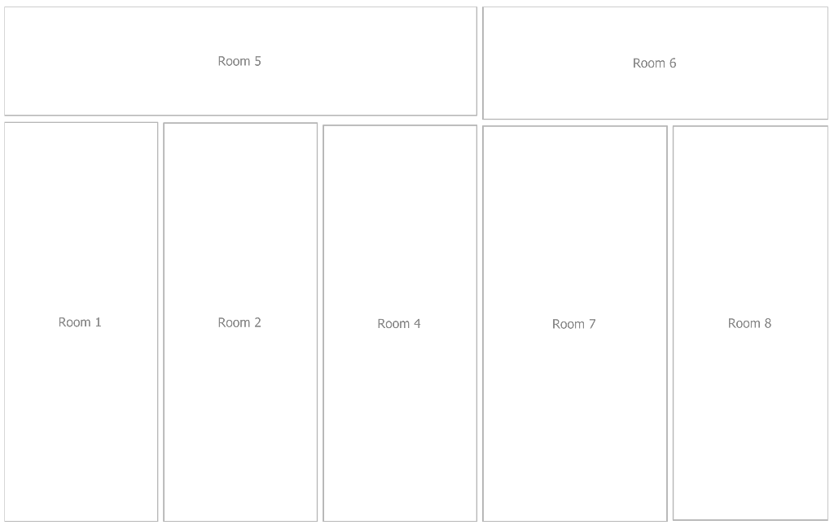Figure 1: AutoCAD 2D Civil Layout of Ceramic Industry

## ****Lighting Layout:****

The lighting design of the ceramic industry has been developed using **DIALux software** to ensure adequate illumination across all functional areas, including production halls, warehouse, offices, and inspection zones. Both **2D and 3D layouts** have been generated to provide a comprehensive view of luminaire placement, lighting zones, and illuminance distribution. The 2D layout illustrates the plan view of fixture locations and lighting coverage, while the 3D view simulates the actual lighting effect within the industrial space, highlighting uniformity, glare control, and compliance with CIE-recommended lux levels (300–500 lux).

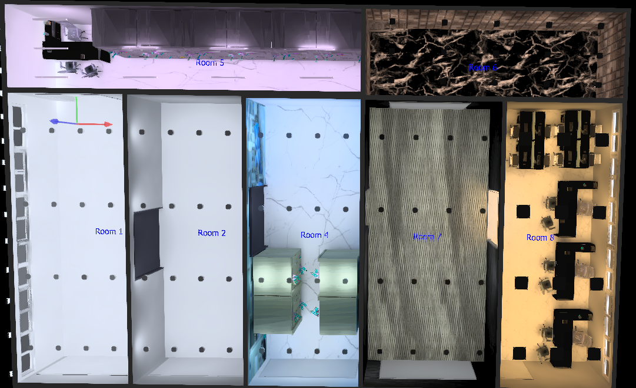 Figure 2: DIALux 3D Lighting Layout – Indoor Area 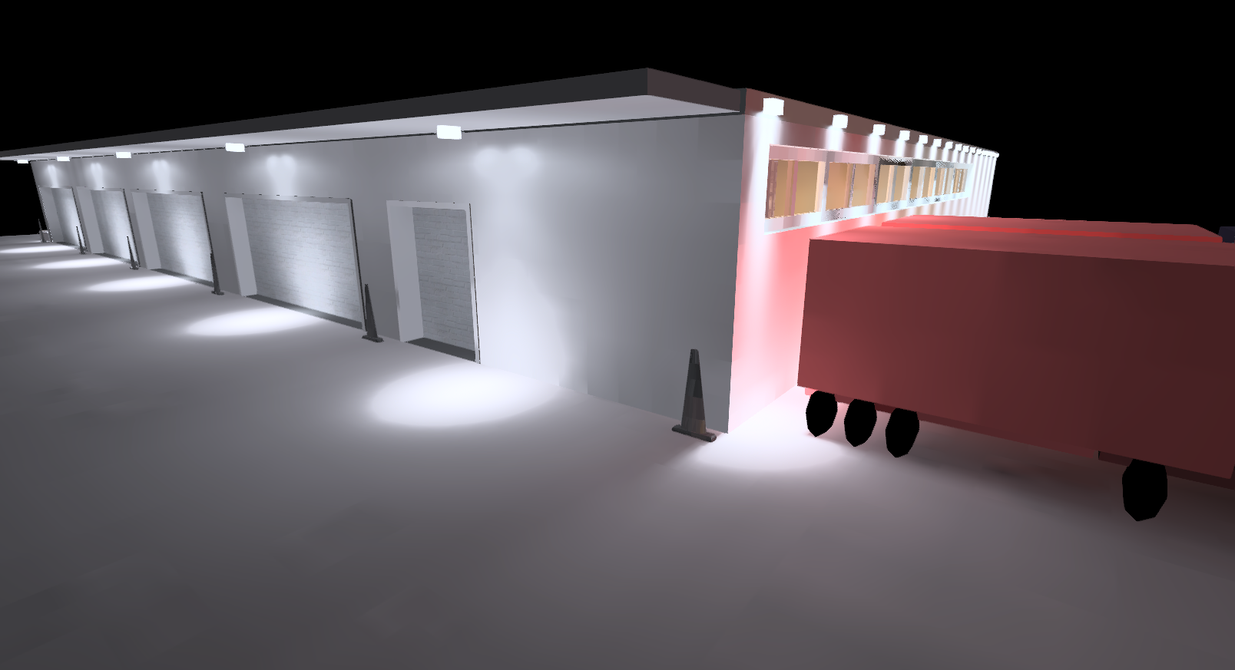 Figure 3: DIALux 3D Lighting Layout – Outdoor Area

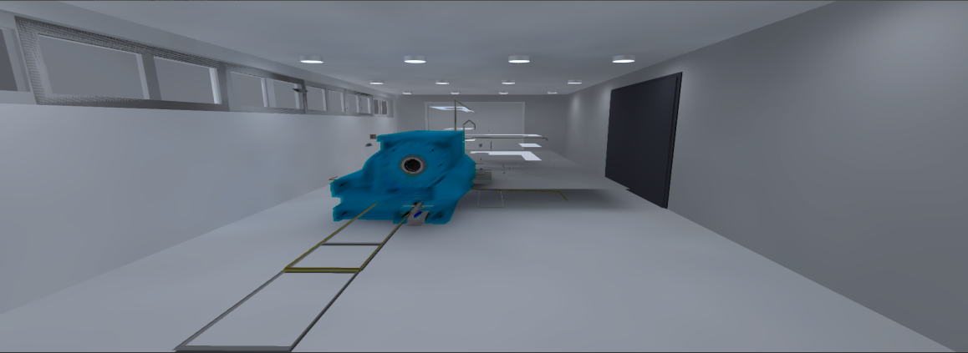Figure 4: Mill – Production Area

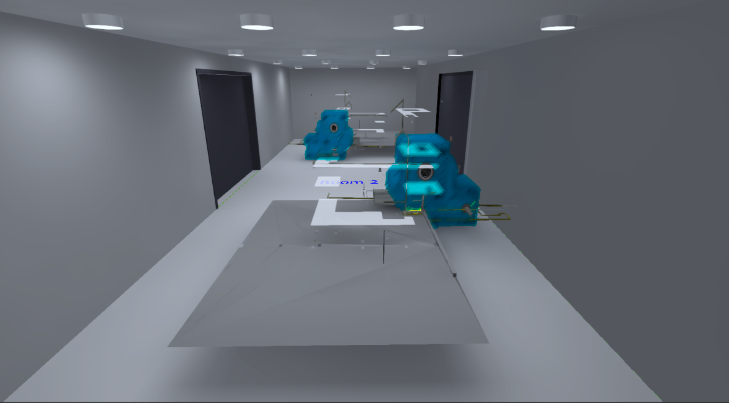Figure 5: Press – Production Area  
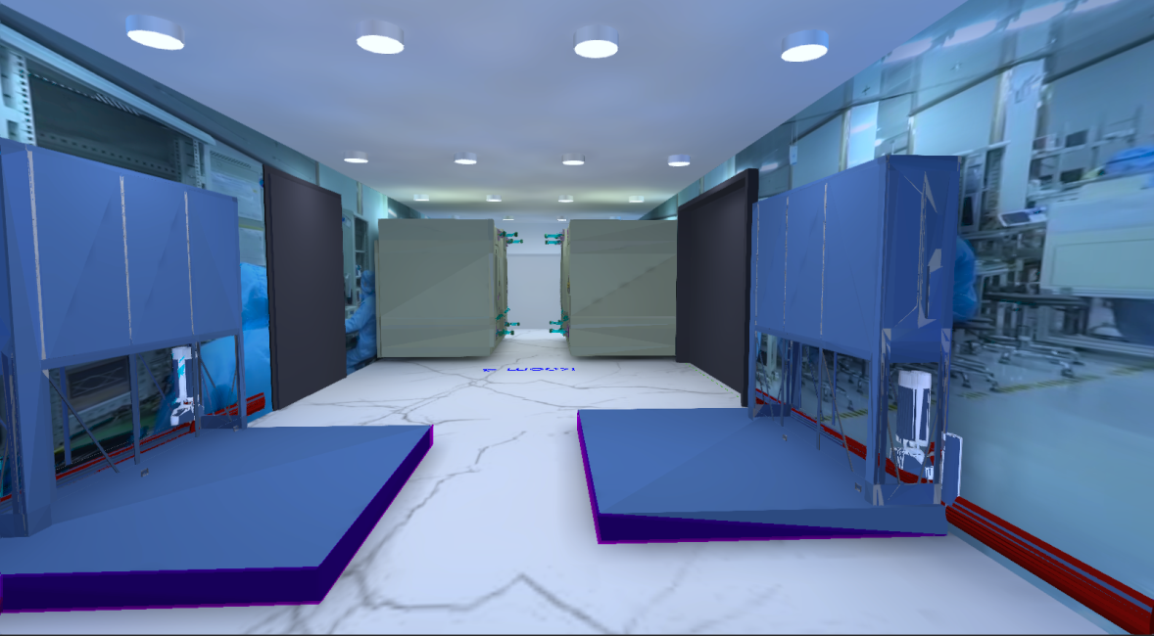 Figure 6: HTF & Packaging – Production Area

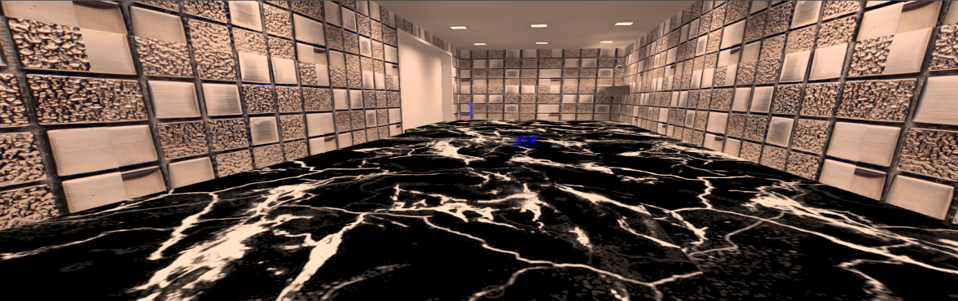 Figure 7: Prayer/kitchen/bathroom – Auxiliary Area

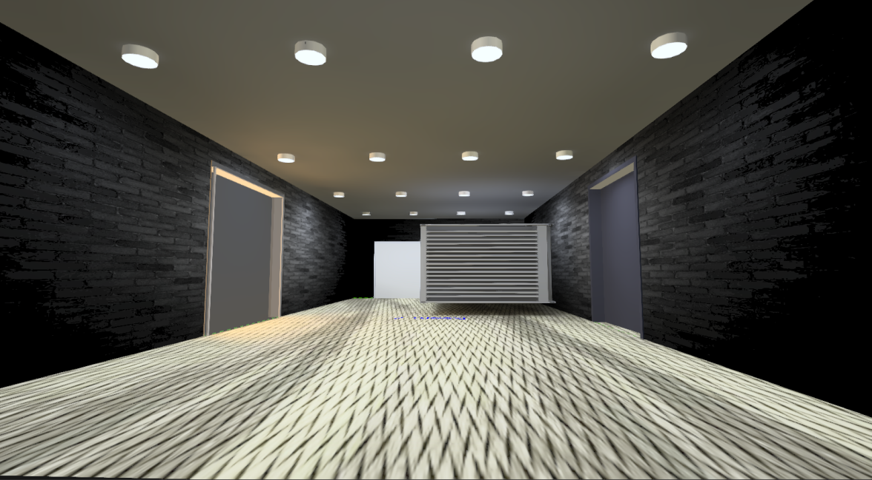 Figure 8: Warehouse – Auxiliary Area

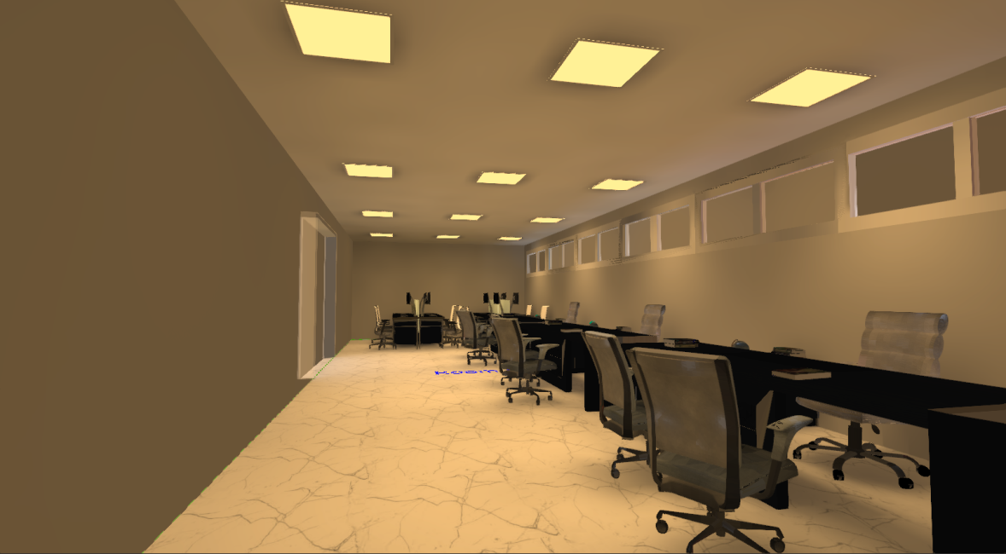 Figure 9: Control Panel & Offices – Auxiliary Area

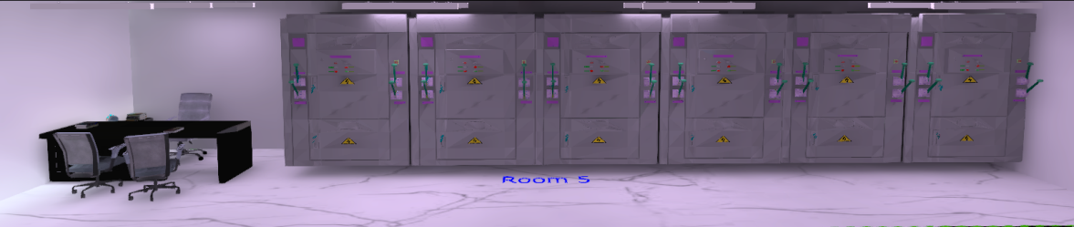 Figure 10: Electrical Distribution – Auxiliary Area

1. **Load Estimation and Demand Calculation:**
2. **Table 1: Load Summary**

|  |  |  |  |  |
| --- | --- | --- | --- | --- |
| **Section** | **Installed Load** | **Future Allowance** | | **Total Load** |
| Mill | Fan: 2(0.5)KW Light: 360W Machines: 37KW Total: 38.360KW | 20% =7672W | | ≈46KW |
| Press | Fan: 2(0.5)KW Light: 360W Machines: 2(22)KW Total: 45.360KW | 20% =9072W | | ≈54KW |
| HTF/Packaging | Fan: 4(0.5)KW Light: 360W Machines: 2(20)+2(0.5) Total: 42.360KW | 20% =8472W | | ≈51KW |
| Warehouse | Fan: 2(0.5)KW Light: 360W Total: 1.360KW | 20% =272W | =1632W | |
| Offices | AC: 2(0.8)KW Light: 408W Total: 2.008KW | 20% =401.6W | =2409.6W | |
| Electrical Distribution | AC: 0.8KW Light: 833.4W Total: 1.6334KW | 20% =326.68W | ≈2KW | |
| Prayer/kitchen/bathroom/Outside | Fan: 2(0.5)KW Light: 315+975W Total: 2290KW | 20% =458W | =2748W | |
| **-** | **-** | **-** | =159.79KW | |

# **Comment:**This table summarizes the **installed loads of all sections in the ceramic industry**, including future allowances, giving a clear view of total expected load (~159.79 kW). It provides a useful basis for demand calculations and proper electrical system planning.

# ****Table 2: Demand Load Calculation****

|  |  |  |  |  |
| --- | --- | --- | --- | --- |
| **Section** | **Total Load (kW)** | **Diversity Factor** | **Demand Factor** | **Demand Load (kW)** |
| Mill | 46 | 0.85 | 0.80 | 46 × 0.85 × 0.80 = 31.28 |
| Press | 54 | 0.85 | 0.80 | 54 × 0.85 × 0.80 = 36.72 |
| HTF / Packaging | 51 | 0.85 | 0.80 | 51 × 0.85 × 0.80 = 34.68 |
| Warehouse | 1.632 | 0.85 | 0.80 | 1.632 × 0.85 × 0.80 ≈ 1.11 |
| Offices | 2.41 | 0.85 | 0.80 | 2.41 × 0.85 × 0.80 ≈ 1.64 |
| Electrical Distribution | 2 | 0.85 | 0.80 | 2 × 0.85 × 0.80 = 1.36 |
| Prayer / Kitchen / Bathroom / Outside | 2.748 | 0.85 | 0.80 | 2.748 × 0.85 × 0.80 ≈ 1.87 |
| **Total** | 159.79 | - | - | **≈108.66 kW** |

Comment: For industrial load estimation, a diversity factor of 0.85 has been adopted, which lies within the standard engineering practice range (0.80–0.90) as recommended by IEC 60364 for mixed motor and lighting loads. This accounts for the fact that not all motors, lighting circuits, and auxiliary equipment operate simultaneously at full load.

1. **Table 3: Phase-wise Assignment**

|  |  |  |  |  |
| --- | --- | --- | --- | --- |
| **Section** | **Demand Load (kW)** | **R (kW)** | **Y (kW)** | **B (kW)** |
| Mill | 31.28 | 10.43 | 10.43 | 10.42 |
| Press | 36.72 | 12.24 | 12.24 | 12.24 |
| HTF / Packaging | 34.68 | 11.56 | 11.56 | 11.56 |
| **Warehouse (Auxiliary)** | 1.11 | 0.37 | 0.37 | 0.37 |
| Offices (Auxiliary) | 1.64 | 1.64 | - | - |
| Electrical Distribution (Auxiliary) | 1.36 | - | 1.36 | - |
| Prayer/Kitchen/Bathroom/Outside (Auxiliary) | 1.87 | - | - | 1.87 |
| **Total Phase Load (kW)** | 108.66 | 36.24 | 35.96 | 36.46 |

Comment:This table clearly shows the phase-wise distribution of demand loads for the ceramic industry, balancing large machinery across R, Y, B phases while assigning auxiliary sections to single phases. It helps visualize load allocation, ensuring minimal unbalance and safer operation of the electrical system.

1. **Table 4: Phase Current Calculation**

$$I=\frac{P×1000}{\sqrt{3}×V×pf}$$*As we know; V = 420V, pf = 0.9*

|  |  |  |
| --- | --- | --- |
| **Phase** | **Load (kW)** | **Current (A)** |
| R | 36.24 | 36.24 × 1000 / 654.3 ≈ 55.4 A |
| Y | 35.96 | 35.96 × 1000 / 654.3 ≈ 55.0 A |
| B | 36.46 | 36.46 × 1000 / 654.3 ≈ 55.7 A |

### Observation:

1. **All phases nearly balanced,** unbalance ~0.7 % (negligible).
2. **Auxiliary single-phase load** (Offices, Electrical Distribution, Prayer/Kitchen, Warehouse) totals ~6 kW, **15.9 A at 420 V**.
3. **Large machinery** (Mill, Press, HTF/Packaging) remain 3-phase to avoid overloads and short circuits.

**Recommendation:** Assign auxiliary loads to different phases (as above) and protect each with **MCBs**.

1. **Transformer Sizing:**
2. **Assumption:**

* Total Demand Load = **108.66 kW**
* System: **3-phase, 420 V (LV)**, **50 Hz**
* Assumed power factor (pf) = **0.90**
* Utility / HV side assumed = **11 kV** (change if your primary is different)
* Diversity & demand already applied in demand load
* Practical margin included to accommodate motor starting and expansion

1. **Basic kVA Requirement:**

Formula:

$$KVA= \frac{kW}{pf} \\ KVA=\frac{108.66}{0.9} \\ KVA=120.73KVA$$

1. **Line Current (3 phase) at 430:**

For 125kVA:

$$I=\frac{KVA×1000}{\sqrt{3}×V} \\ I=\frac{125×1000}{\sqrt{3}×420} \\ I=171.83A$$

For 150kVA:

$$I=\frac{KVA×1000}{\sqrt{3}×V} \\ I=\frac{150×1000}{\sqrt{3}×420} \\ I=206.19A$$

1. **Recommendation:**

Based on the calculated three-phase line currents at 420 V (125 kVA = 171.83 A, 150 kVA = 206.19 A) and considering motor starting currents, short-term overloads, and future modest expansion, it is recommended to select a **150 kVA, 11 kV / 420 V, 3-phase transformer**. This rating provides sufficient operational margin and ensures reliable power supply to all production and utility loads.

1. **Busbar Scheme:**

For the ceramic industry, a **dual-level busbar arrangement** is proposed to ensure operational flexibility, ease of maintenance, and effective fault management:

* **Production Area:** Double Busbar (DBDB) configuration is adopted to allow critical production loads (mills, presses, HTF, packaging) to remain operational during maintenance or faults on one busbar. Bus couplers with circuit breakers are included for selective isolation and redundancy.
* **Non-Critical Areas:** Single busbar with sectionalizers is used for offices, warehouse, HR, kitchen, and utility loads to optimize cost while maintaining safety and reliability.
* **Environmental & Sustainability Considerations:** Busbar design minimizes energy losses, supports efficient load distribution, and allows future expansion without major infrastructure changes. Proper earthing, insulated supports, and low-loss copper/aluminium busbars are recommended.

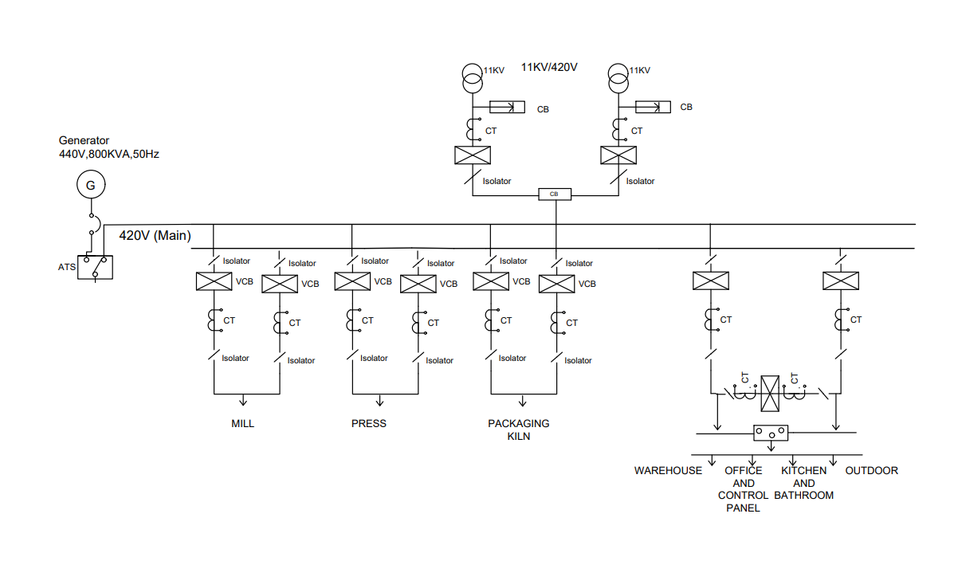

**AND  
ELEC-DIST**

Figure 11: Single Line Diagram

## ****Single-Line Diagram (SLD) Description:****

The single-line diagram (Figure 11) illustrates the electrical distribution of the ceramic industry, including production, utility, and administrative areas:

1. **Power Sources:**
   * Two **11 kV incoming feeders** supply the main transformer bank.
   * A **backup generator (440 V, 800 kVA, 50 Hz)** is connected through an Automatic Transfer Switch (ATS) to provide emergency power in case of utility failure.
2. **Transformer Arrangement:**
   * Main transformer: **150 kVA, 11 kV / 420 V, 3-phase** supplies all plant loads.
   * A second identical transformer is kept as a **cold spare** in a dedicated shelter for quick replacement during maintenance or fault.
3. **Busbar Configuration:**
   * **Production Areas (MILL, PRESS, PACKAGING/KILN):** **Double Copper Busbar (DBDB)** configuration ensures high reliability and allows maintenance on one busbar without interrupting critical production loads.
   * **Non-Critical Areas (Warehouse, Offices, Kitchen, Outdoor, Control Panel):** **Single Copper Busbar** with sectionalizers is sufficient for light loads, optimizing cost while maintaining safety.
4. **Switchgear and Protection:**
   * **VCBs** (Vacuum Circuit Breakers) and **isolators** are installed at each feeder for selective protection and isolation.
   * **Current transformers (CTs)** are provided for monitoring and protection relays.
   * **ATS** ensures seamless transfer between utility and generator supply during outages.
5. **Design Considerations:**
   * **Copper busbars** are selected for all main feeders to minimize energy losses and provide long-term reliability.
   * Sufficient spare capacity in busbar and cable ducts is provided **for future load expansion**.
   * Proper earthing and insulation are implemented according to IEC 60364 standards.
6. **Main and Sub-Distribution:**

* **Main Distribution Panel (MDB):** Sized to carry the total calculated load of **108.66 kW**, considering **future allowance and transformer rating (150 kVA, 420 V)**. Rated current and short-circuit capacity are selected to accommodate all production and auxiliary loads with a safe margin.
* **Sub-Distribution Panels (SDBs):** Located strategically across production, warehouse, and administrative areas. Panels are rated according to the branch loads and demand factors for each section.
* **Design Considerations:** Main and sub-distribution panels include provisions for MCCBs/fuse protection, metering, monitoring, and easy maintenance. Cable feeders are sized based on line currents, voltage drop limits, and diverting factors. The arrangement ensures selective coordination, protection, and operational reliability.

1. **Cable Sizing:**

Cable sizing is a critical aspect of electrical system design to ensure safe and reliable operation. The purpose of cable sizing is to select a conductor that can carry the expected current without excessive voltage drop or overheating, while also withstanding short-circuit conditions.

1. **Table 5: Cable Size**

|  |  |  |  |  |
| --- | --- | --- | --- | --- |
| **Section** | **Demand Load (kW)** | **Phase Current (A)** | **Recommended Cable (Underground, XLPE/PVC)** | **Justification** |
| Mill | 31.28 | 55 | 3-core, 70 mm² Cu + SWA | Heavy machinery; oversized for future load, low voltage drop, mechanical protection |
| Press | 36.72 | 55 | 3-core, 70 mm² Cu + SWA | Large motors; future-proof, underground hazard-safe |
| HTF / Packaging | 34.68 | 55 | 3-core, 70 mm² Cu + SWA | Motors and auxiliary equipment; accommodates future expansion |
| Warehouse (Auxiliary) | 1.11 | 1 | 3-core, 10 mm² Cu | Lighting and fans; slightly oversized for future loads |
| Offices (Auxiliary) | 1.64 | 2 | 3-core, 10 mm² Cu | AC and lighting; margin for additional devices |
| Electrical Distribution (Auxiliary) | 1.36 | 2 | 3-core, 10 mm² Cu | Auxiliary lighting/panels; underground protection |
| Prayer / Kitchen / Bathroom / Outside | 1.87 | 2 | 3-core, 10 mm² Cu | Fans and lighting; future-proof and underground safe |

**Notes:**

* All main cables (Mill, Press, Packaging) are **SWA (armoured) for mechanical protection**.
* Voltage drop kept well below 5%, even with future load growth.
* Underground installation, PVC/XLPE insulated, suitable for soil conditions and ambient temperature.

1. **Table 6: Earthing and Grounding Cable**

|  |  |  |
| --- | --- | --- |
| **Section / Equipment** | **Earthing Cable** | **Justification** |
| Main Plant (Mill, Press, Packaging) | 35–50 mm² Cu | Safely carries fault currents; oversized for future expansion |
| Auxiliary / Lighting / Offices | 16–25 mm² Cu | Sufficient for small loads; future-proof for added equipment |
| Transformers / Distribution Panels | 50 mm² Cu | Handles maximum short-circuit current; ensures low earth resistance |
| Earth Rods / Ground Grid | 25–35 mm² Cu | Connects steel rods/plates; maintains <1 Ω resistance |

**Future-Safe Design Principles:**

* Oversize main and earthing cables for **load growth and hazard protection.**
* Use armoured cables forunderground mechanical protection.
* Multiple earth points and low-resistance connections for safety and reliability.

1. **Breaker Sizing:**
2. **Table 7: Introduction of Breakers**

|  |  |
| --- | --- |
| **Breaker Type** | **Definition** |
| MCCB (Molded Case Circuit Breaker) | Protects cables and equipment from overload and short-circuit. Used for medium to large currents (up to ~1000 A). Adjustable trip settings. Ideal for motors, feeders, panels. |
| MCB (Miniature Circuit Breaker) | Small, compact breaker for low-current circuits (lighting, small AC, auxiliary loads). Protects from overload and short-circuit, typically <100 A. |
| CB (Circuit Breaker) | General term for breakers; can be AC or DC, low or high voltage. Protects circuits from overload/short-circuit. |
| VCB (Vacuum Circuit Breaker) | High-voltage breaker using vacuum arc quenching. Used for 11 kV – 33 kV switchgear in industrial plants. |
| VCCB (Vacuum Current Circuit Breaker / VCB variant) | High-voltage breaker with current-limiting features; used in HV distribution for fault protection andswitching. |

1. **Breaker Sizing Criteria:**

• **Breaker Rating > Full Load Current (FLC)**

* Select nominal rating slightly higher than running phase current.

• **Short-Circuit Rating (kA)**

* Must withstand **prospective fault current** at installation point.

• **Trip Characteristics**

* Motors: use **type D** or **inverse time** trip.
* Lighting / Aux: use **type B** MCB.

• **Coordination with Cable**

* Breaker rating must **not exceed cable thermal limit**.

• **Future Proofing**

* Allow 10–20% extra margin for **future load growth**.

1. **Table 8: Department wise Breaker Sizing**

|  |  |  |  |  |
| --- | --- | --- | --- | --- |
| **Section / Dept** | **Demand Load (kW)** | **Phase Current (A)** | **Recommended Breaker Type** | **Rated Current (A)** |
| Mill | 31.28 | 55 | MCCB | 63 A, 3-pole |
| Press | 36.72 | 55 | MCCB | 63 A, 3-pole |
| HTF / Packaging | 34.68 | 55 | MCCB | 63 A, 3-pole |
| Warehouse (Auxiliary) | 1.11 | 1 | MCB | 10 A, 1-pole |
| Offices (Auxiliary) | 1.64 | 2 | MCB | 16 A, 1-pole |
| Electrical Distribution (Auxiliary) | 1.36 | 2 | MCB |  |
| Prayer/Kitchen/Bathroom/Outside | 1.87 | 2 | MCB | 16 A, 1-pole |
| Main 11 kV Feed / Incoming | 108.66 (total) | ~160 A (11 kV) | VCB | According to HV design |
| Transformer Feeder | According to transformer rating | According to load | VCCB | According to HV design |

### Notes

1. **MCCB**: Use for all **medium current industrial motors and feeders**. Adjustable trip settings improve motor start-up reliability.
2. **MCB**: Use **for lighting, AC, and auxiliary circuits**; compact and cost-effective.
3. **VCB / VCCB**: Use at **high-voltage incoming lines and transformer feeders**. Provides safe switching and fault isolation.
4. **Coordination**: Breakers must coordinate with **cable size** to prevent nuisance tripping and cable damage.
5. **Future-Proofing**: Allow **10–20% extra capacity** in breaker rating to accommodate plant expansion and unforeseen loads.
6. **Illumination Design:**
   1. **Table 9: Types of Luminaires**

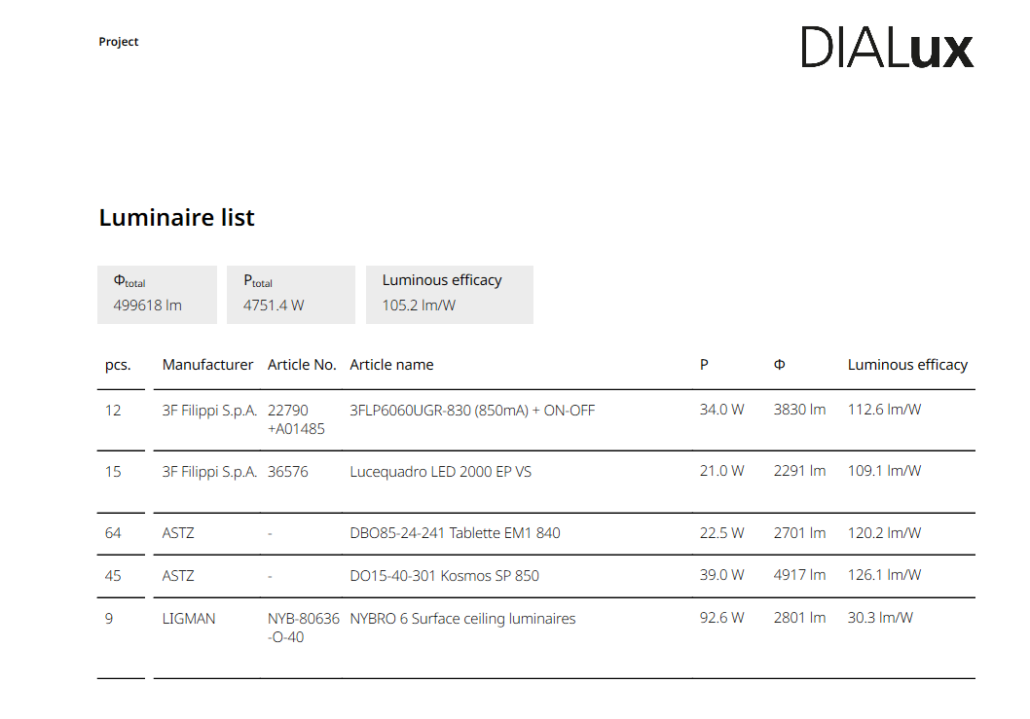

Comment: The lighting design prepared for the ceramic industry facility provides an efficient, uniform, and task-appropriate illumination level across all major operational zones. The selected luminaires deliver a combined luminous flux of 49,961.8 lm with a total connected load of 4.75 kW, resulting in an overall system efficacy of 105.2 lm/W, which aligns well with industrial-grade energy-efficiency standards.

High-efficacy fixtures from 3F Filippi, ASTZ, and LIGMAN have been strategically deployed to ensure proper visibility for ceramic processing, material handling, and machine operation areas. Most installed fixtures operate above 100 lm/W, making the design suitable for continuous industrial operations where reliability, glare control, and low maintenance are essential. One low-efficacy fixture (30.3 lm/W) is likely used for specific accent or localized lighting requirements.

The quantity and placement of luminaires demonstrate proper illumination zoning according to the functional needs of ball mills, HTF machines, packing area, and storage sections. Overall, the lighting design enhances worker safety, reduces fatigue, and ensures clear visual performance required in ceramic production environments.

* 1. **Table 10: Mounting Height**

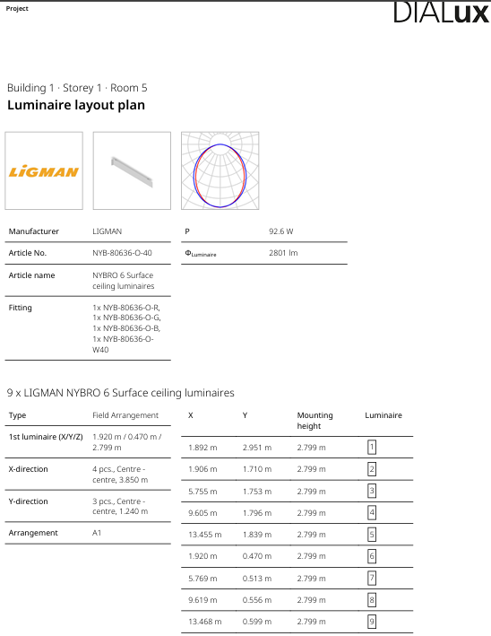

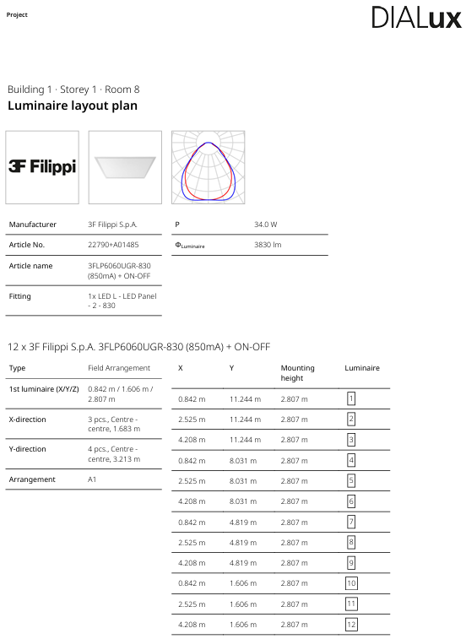

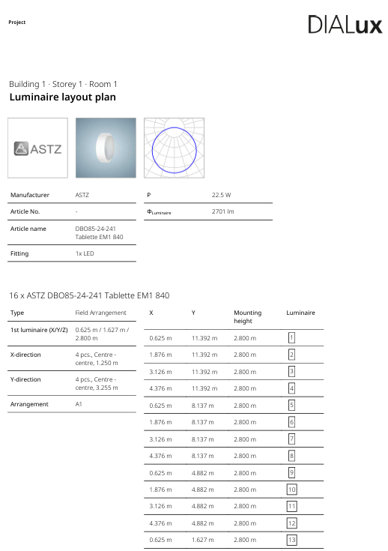

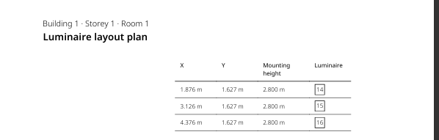

Comment: The rest of the rooms are same as the room 1. The luminaire layout for the ceramic production room shows the placement of 16 ASTZ DBO85-24-241 Tablette EM1 840 LED fixtures, each providing 2701 lm at 22.5 W. The luminaires are mounted at a height of 2.8 m, ensuring uniform light distribution across the workspace. The grid arrangement (A1) with equal spacing in both X and Y directions provides consistent illumination levels suitable for industrial tasks, material inspection, and machine operation.

The spacing (approx. 1.25 m centre-to-centre along X-direction and 3.255 m along Y-direction) is designed to avoid dark zones and to maintain visual comfort for workers, especially in areas where ceramic material handling and equipment operation require clear visibility. The symmetrical layout enhances safety by minimizing shadows around machinery and reduces worker fatigue during long production hours.

Overall, this luminaire arrangement supports a well-balanced industrial lighting environment that aligns with recommended lux levels for ceramic processing facilities.

* 1. **Calculation**

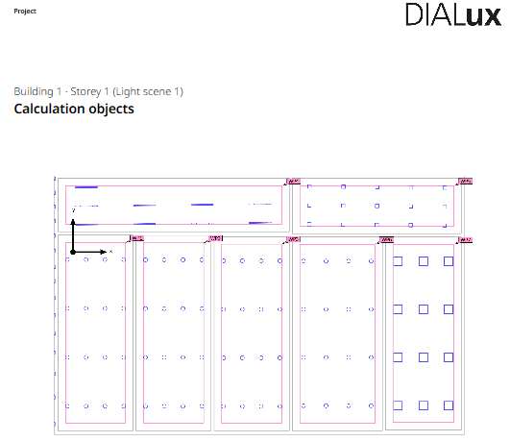

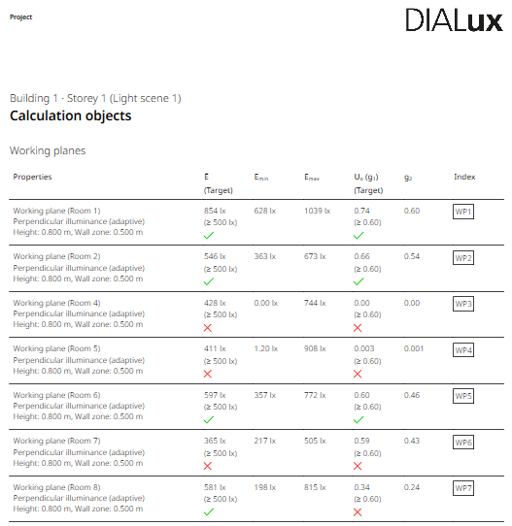

1. **Summary:**

The electrical power distribution system of the ceramic industry is designed for high reliability, safety, and future expansion. Two 11 kV utility feeders supply power through a pair of 150 kVA transformers, where one transformer operates as the main source while the second remains as a dedicated spare for emergency replacement. A 440 V, 800 kVA generator provides backup power through an Automatic Transfer Switch (ATS), ensuring uninterrupted operation during utility failures.

A copper busbar system is used throughout the plant to enhance conductivity, reduce losses, and improve long-term durability. Critical production sections such as the Mill, Press, and Kiln are connected through a robust double busbar arrangement to allow maintenance without interrupting operations. Non-critical areas, including the warehouse, offices, kitchen, and outdoor loads, are supplied through a single busbar system for optimized cost and efficiency. Each feeder is equipped with vacuum circuit breakers (VCBs), isolators, and current transformers (CTs) to ensure selective protection and operational safety.

Overall, the SLD layout ensures reliable power distribution, efficient fault management, proper segregation of critical and non-critical loads, and readiness for future expansion of the facility.

1. **Refferences:**

**IEC 60364** – Electrical Installations of Buildings. International Electrotechnical Commission.

**IEC 60947** – Low Voltage Switchgear and Controlgear Standards. International Electrotechnical Commission.

**IEEE Std 141 (Red Book)** – Recommended Practice for Electric Power Distribution in Industrial Plants.

**IEEE Std 399 (Brown Book)** – Recommended Practice for Industrial and Commercial Power System Analysis.

**NFPA 70 – National Electrical Code (NEC)**, National Fire Protection Association.

**Pakistan Electric Rules (PER)** – Government of Pakistan, Ministry of Energy (Power Division).

**PEC Electrical Engineering Design Guidelines**, Pakistan Engineering Council.

**Pakistan Cables Technical Handbook** – Cable Sizing, Ampacity Charts, and Derating Factors.

**Schneider Electric – Electrical Installation Guide** (2023 Edition).

**Siemens Industrial Power System Handbook** – System Design, Protection & Coordination.

M.-T. Ansari, “Ceramic‑Plant‑SLD‑and‑DIALux‑Design,” GitHub repository, Apr. 2025. [Online]. Available: [https://github.com/Muhammad-Taha-Ansari/Ceramic-Plant-SLD-and-DIALux-Design](https://github.com/Muhammad-Taha-Ansari/Ceramic-Plant-SLD-and-DIALux-Design?utm_source=chatgpt.com)